Project Planning Phase
Project Planning Template (Product Backlog, Sprint Planning, Stories, Story Points)
Date | 14 July 2026
Team ID
Project Name | HouseRent India — MERN Property Rental & Sale Platform
Maximum Marks | 5 Marks

Product Backlog, Sprint Schedule, and Estimation (4 Marks)
Use the below template to create product backlog and sprint schedule
Sprint | Functional Requirement (Epic) | User Story Number | User Story / Task | Story Points | Priority | Team Members
Sprint-1 | Registration | USN-1 | As a user, I can register by entering my name, email, password, phone, and security question. | 2 | High | All
Sprint-1 | Login | USN-2 | As a user, I can log in with email & password. | 1 | High | All
Sprint-1 | Forgot Password | USN-3 | As a user, I can reset my password via my security question. | 2 | Medium | Backend Dev
Sprint-1 | Property Listing | USN-9 | As an owner, I can add a property with photos and details. | 3 | High | Full-Stack Dev
Sprint-1 | Property Search | USN-4 | As a renter, I can search & filter properties. | 3 | High | Frontend Dev
Sprint-1 | Booking Request | USN-5 | As a renter, I can send a booking/purchase request. | 3 | High | Full-Stack Dev
Sprint-1 | Booking Approval | USN-11 | As an owner, I can approve/reject booking requests. | 3 | High | Backend Dev
Sprint-1 | Booking Tracking | USN-6 | As a renter, I can view booking status and cancel one. | 2 | Medium | Frontend Dev
Sprint-1 | Property Management | USN-10 | As an owner, I can edit or delete my listings. | 1 | Medium | Full-Stack Dev
Sprint-2 | Chat | USN-7 | As a renter/owner, I can chat once a booking is sent. | 3 | Medium | Full-Stack Dev
Sprint-2 | Admin Dashboard | USN-13 | As an admin, I can view stats, users, properties, bookings. | 3 | Medium | Backend Dev
Sprint-2 | User Management | USN-14 | As an admin, I can activate/deactivate users. | 1 | Medium | Backend Dev
Sprint-2 | Listing Moderation | USN-15 | As an admin, I can request removal of a listing. | 2 | Low | Full-Stack Dev
Sprint-2 | Listing Removal Response | USN-12 | As an owner, I can consent/decline a removal request. | 2 | Low | Frontend Dev
Sprint-2 | UI Overhaul | — | Rebuild theme to indigo/navy design system with reusable Navbar/HeroBanner/PageHeaderCard components. | 3 | Low | Frontend Dev

Project Tracker, Velocity & Burndown Chart (4 Marks)
Sprint | Total Story Points | Duration | Sprint Start Date | Sprint End Date (Planned) | Story Points Completed (as on Planned End Date) | Sprint Release Date (Actual)
Sprint-1 | 20 | 6 Days | 14 Jul 2026 | 19 Jul 2026 | 20 | 19 Jul 2026
Sprint-2 | 14 | 6 Days | 21 Jul 2026 | 26 Jul 2026 | — | —

Velocity:
With a 6-day Sprint-1 duration and a velocity of 20 story points, the team's average velocity (AV) is 20 ÷ 6 ≈ 3.3 story points per day.

Burndown Chart:
A burndown chart shows work remaining versus time, tracking Sprint-1's progress toward zero remaining story points by the end of the sprint.
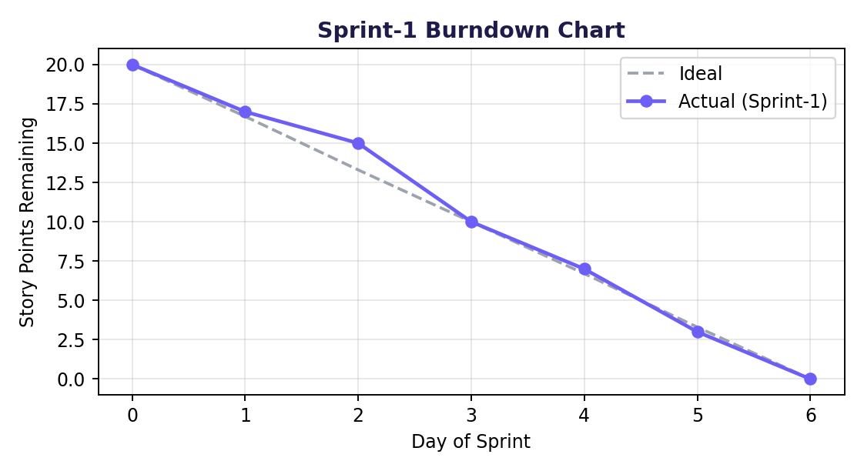
Figure 1: Sprint-1 burndown — actual vs. ideal story points remaining

